Name: BSE No.19
Regression
Target names: 1) Electricity Price, and 2) Electrical Power Demand
Number of samples: Initially 50000, convert to daily format by averaging each 96 samples. The sample size must be 50000/96 = 521.
Number of Inputs: 10 variables, do not consider timestamp as input.
Cross Validation: 5-Fold
Models: Lasso Regression (LR), Support Vector Regression (SVR), and Extreme Gradient Boosting Regression (XGBR).
Optimizers: Ladybug Beetle Optimization Algorithm (LBOA) and Heavy Rain Optimization Algorithm (HROA).
Convergence: Based on RMSE.
Report Search spaces
Give Hyperparameter for all iterations.
Report Run Time
Metrics: R², RMSE, COV, AARD, and MAEM.
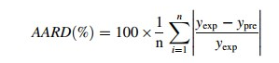
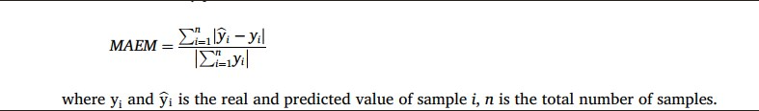
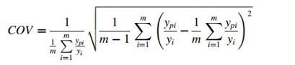

Statistical Wilcoxon test
REC Curves
Sensitivity: FAST.
Uncertainty Analysis: Based on Monte Carlo method

